Which we think we can make better:

1. Login frame:

The problem is if user enter wrong passwords and name, there is not even a massage box show that your user name or password is wrong.

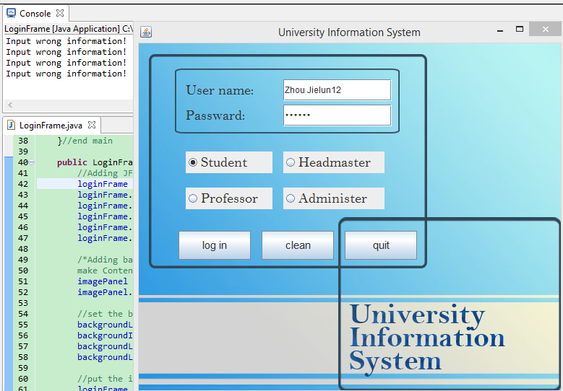

1. Student –schedule

We have achieved it, but the massage box looks too urgy.

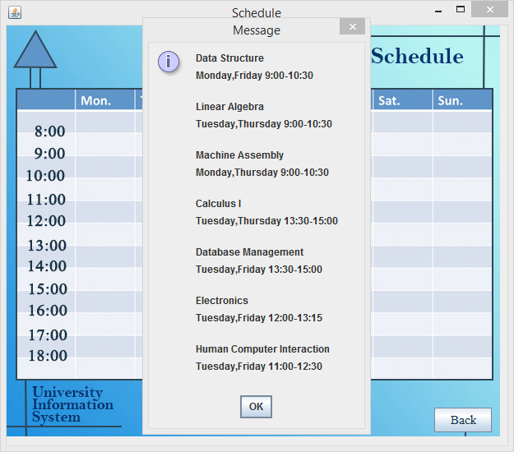

1. Student-information

The UI has done the part but there are not the words like the email the date and so on. We need to fill it later. The reset button can set the password. But the problem is if user has not entered the password, it will log off which means close all the window. Like in this frame, if user click “ok”, all the windows will be closed which seems very strange to user. And if user click the close button of message box, all the windows also will be closed.

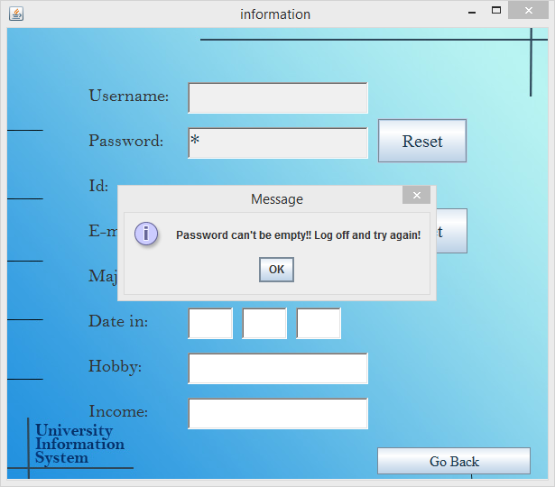

1. Student –career plan

There are several careers will be chosen for student, there are at most three, but when if come to the last, there are still “next” button, it is not rigorous.

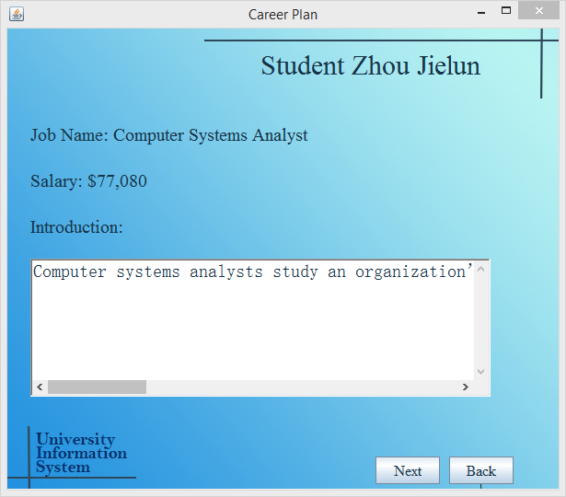

1. Student—project

There is only 1 button working which is “back”.

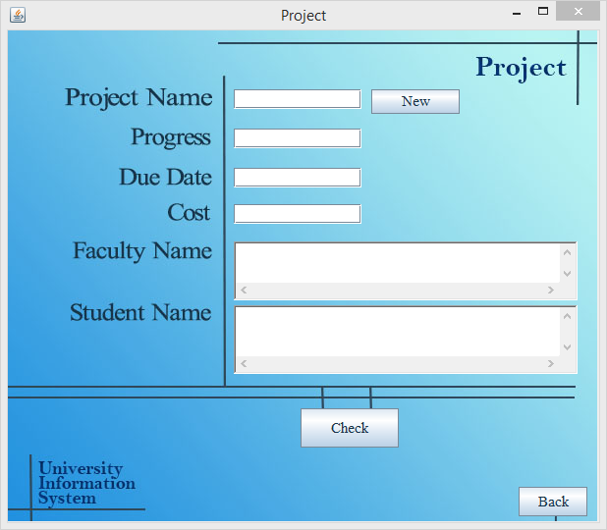

1. Faculty-----grading frame

If user click “challege” button, then will comes out a message box: this button is not for you. Why not just disable this button?

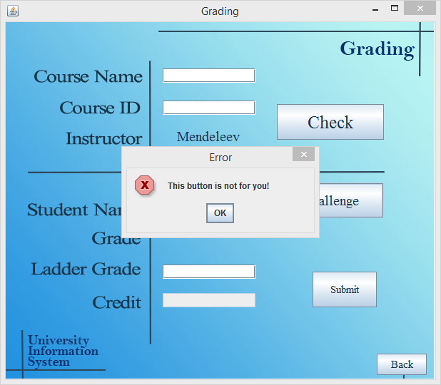

1. Admin—modify bulletin

If user click modify and enter nothing those two message boxes will comes out again and again. Even I want to close the message boxes, click the close button, but I cannot.

